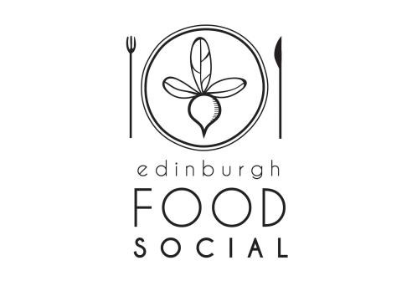
Edinburgh Food Social
Indoor Food & Craft Market
@ The Biscuit Factory
#EdIndoorMarket

Booking Form

The Market will operate from 12-6pm on the last weekend of the month. Bookings are for both days. If you wish to take up the offer of stall space, please complete all relevant sections of this form and return them with a copy of your current liability insurance (and for all food producers, a copy of your current Food Hygiene Certification) to the address at the foot of this form. This form is for food and craft producers – craft producers, please just skip the food related sections of the form.

Company Name: Company Address:
Post
Note: An alternative address must be provided for PO Box addresses.

Tel No: Email: Website:
Contact Name: Contact Mobile: Social Media:
Dates of Market Applying For:

Product types available for sale from the stall:

Product | Loose or pre-  packed | Source of product | Place of production

Food Hygiene: All food producers

Do you have a basic or intermediate food hygiene certificate?

Which environmental health authority are you registered with?

Please provide a copy of your registration confirmation to accompany your application plus a copy of your hygiene certification for all staff attending the event.

Meat Producers:

What is your holding number?……………………………………………………………..

Do you rear your own produce? Yes No

Where will your animals be slaughtered?…………………………………………………. Contact phone no. for above:……………………………………………………………….. Where will your product be packed?………………………………………………………..
Contact phone no. for above:………………………………………………………………..

Transport:

Registration number of vehicle(s):

Gas and Electrical appliances

Will you be doing cookery demonstrations / tasting of hot food?
Please confirm gas equipment has a current Gas Safe safety certificate
NOTE: The sale of finished cooked produce is not permitted at this event without prior agreement.

Electricity:

Do you require electricity for your stall or chillers displays?
There is an additional charge for electricity as this has to be set up by an external electrical company. The cost of set up and running is £25 per day.
Please confirm all electrical appliances used carry a current PAT label and provide electrical usage for each piece of equipment.

Liability Insurance & Food Hygiene Certification:

Please provide a copy of your current Certificate of Insurance including Public Liability Insurance to accompany this Booking Form.
All food producers must provide a copy of your current Food Hygiene Certification
No bookings will be accepted without this information.

Terms & Conditions

A full set of terms and conditions and a Liability Statement will be sent to all stall holders prior to the market.

Payment

The cost of the stall hire for a 6ft x 2.3ft trestle table is £30.00 per day and the market will run for 2 days.
£60.00 is payable in advance of the market per stall. We will send you payment details once your space at the market has been confirmed. Payment is due within 5 days of your confirmed space.

Double stalls and food trucks are charged at £50.00 per day so £100 is payable in advance for the 2 days.

Please confirm stall space required: 1 Stall / 2 Stalls / Food Truck (Each Stall = 6ft / 2.3ft)
Please complete the above booking form and return with the following documents where required and check the list below to confirm all relevant documents are enclosed:

All producers

Current liability insurance certificate

Food producers

Copy of registration details with local authority as place of food production
Copy of hygiene certification for each member of staff attending the event
Current GAS Safe certificate for gas appliances where required
Current PAT certificate for electrical appliances where required

Signed: Print Name: Date:

Please sign above and return with the accompanying documentation as required for food producers or craft producers to:

Eleanor Cunningham Edinburgh Food Social Office 1F1
The Biscuit Factory
4-6 Anderson Place
Edinburgh
EH6 5NP

OR scan and email: edinburghfoodsocial@edinburghlarder.co.uk

Note: Submission of this Booking Form does not guarantee stall space which will be allocated only on confirmation of booking.

#EdIndoorMarket

