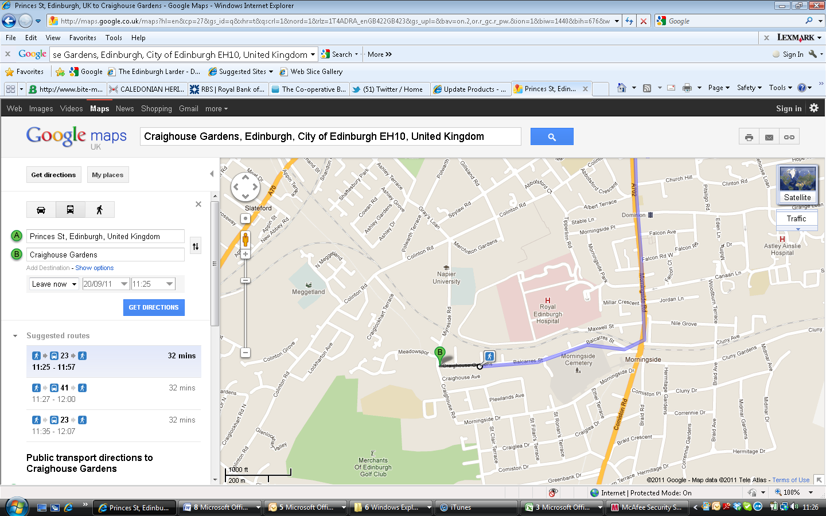

The meeting place for our mushroom foraging course on Sunday 25th of October from 9.30-12.30am is shown on the map above where the ‘B’ sign is. If you’re driving, the easiest route is to proceed onto Colinton Road from Morningside Road, passing Napier Merchiston Campus; turn left down Myreside Road at the 5 way junction. Myreside becomes Craighouse Road; when you get to the junction with Craighouse Gardens on the left, there is an entrance in the wall with a map of the park outside just opposite. Drivers should be able to park for free in Craighouse Road, Gardens or Myreside on a Sunday. The number 23 bus goes from the centre of town directly to the meeting place and the number 16 bus also goes to Morningside Road if you’re happy to walk along Balcares Street from there.

